Your name:

Class being rounded:

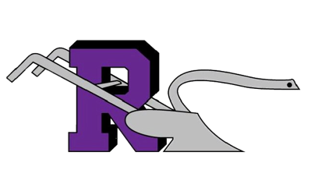
Date:

1st-6th Rounds Sheet

Rounds Focal Question: [Type your learning question/problem here]:

Reflection: [To be completed by observer]:

I saw:

I heard:

I saw:

I heard:

I Wonder:

Circle the strategies that were used.

- Writing (to learn or learning to write)
- Collaboration
- Organization (physical or cognitive)
- Inquiry (two-way questioning)
- Reading (to learn or learning to read)
- Classroom Talk
- Scaffolding

